**9. ReactJS-HOL**

src/components/ListofPlayers.js

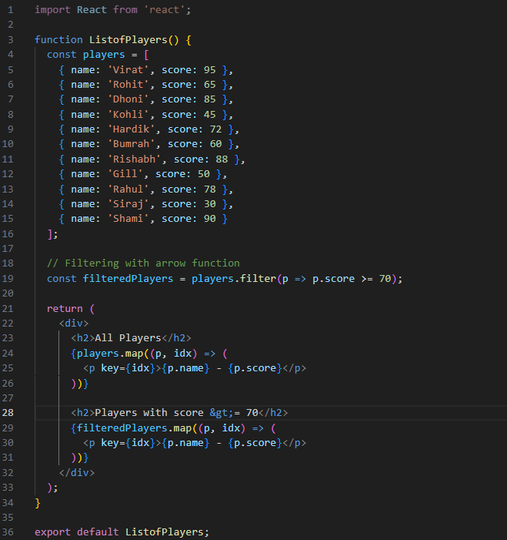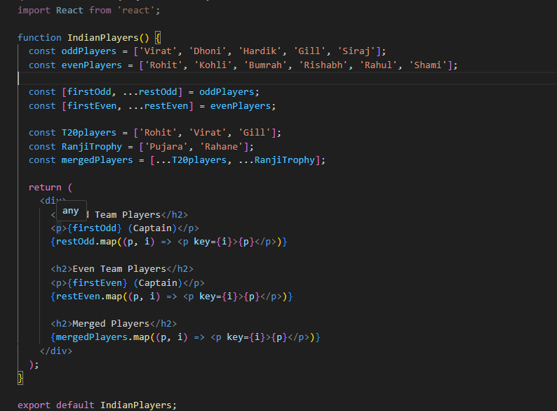

Src/components/IndianPlayers.js

App.js

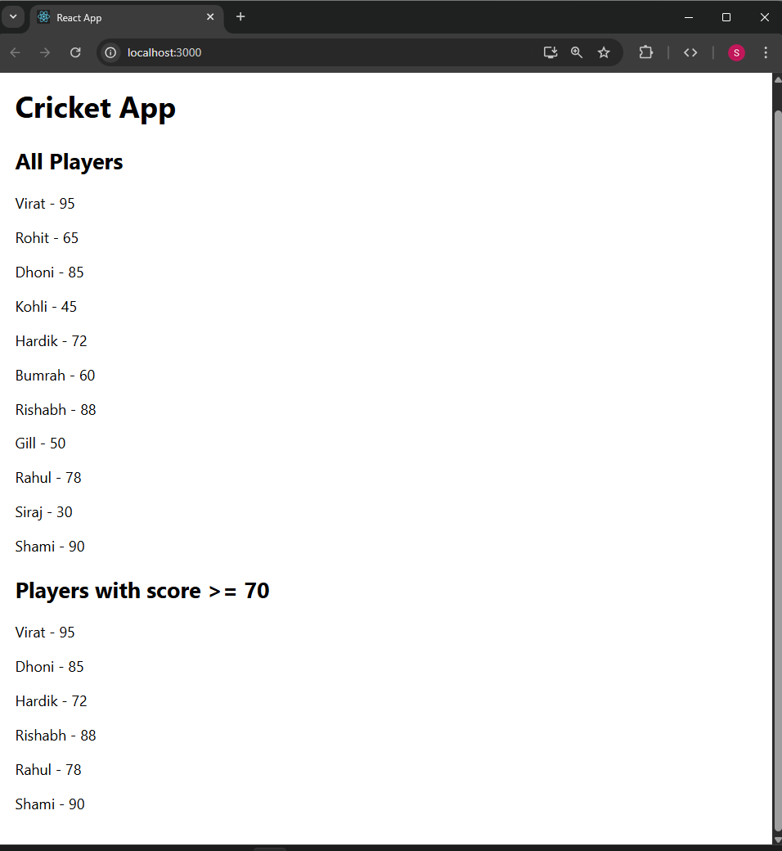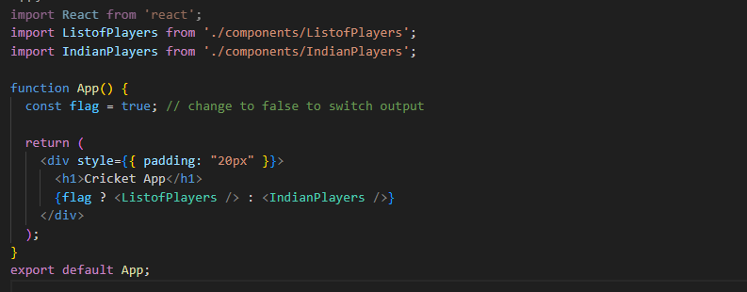

**10. ReactJS-HOL**

import React from 'react';

function App() {

  const heading = <h1>Office Space Rental</h1>;

  const imageUrl = "https://via.placeholder.com/600x300?text=Office+Space";

  const office = {

    name: "Tech Park Tower",

    rent: 75000,

    address: "123 Business Street, Hyderabad"

  };

  const officeList = [

    { name: "Startup Hub", rent: 55000, address: "45 Innovation Road, Vizag" },

    { name: "Global Plaza", rent: 65000, address: "88 Corporate Avenue, Chennai" },

    { name: "Eco Tower", rent: 48000, address: "12 Green Lane, Bangalore" },

    { name: "Skyline Offices", rent: 90000, address: "77 Sky Street, Mumbai" }

  ];

  const rentStyle = (rent) => ({

    color: rent < 60000 ? 'red' : 'green',

    fontWeight: 'bold'

  });

  return (

    <div style={{ padding: "20px", fontFamily: "Arial" }}>

      {heading}

      <img src={imageUrl} alt="Office Space" style={{ width: "100%", height: "auto", marginBottom: "20px" }} />

      <h2>{office.name}</h2>

      <p style={rentStyle(office.rent)}>Rent: ₹{office.rent}</p>

      <p>Address: {office.address}</p><hr />

      <h2>Available Office Spaces</h2>

      {officeList.map((o, index) => (

        <div key={index} style={{ marginBottom: "15px" }}>

          <h3>{o.name}</h3>

          <p style={rentStyle(o.rent)}>Rent: ₹{o.rent}</p>

          <p>Address: {o.address}</p>

        </div>

      ))}

    </div>

  );

}

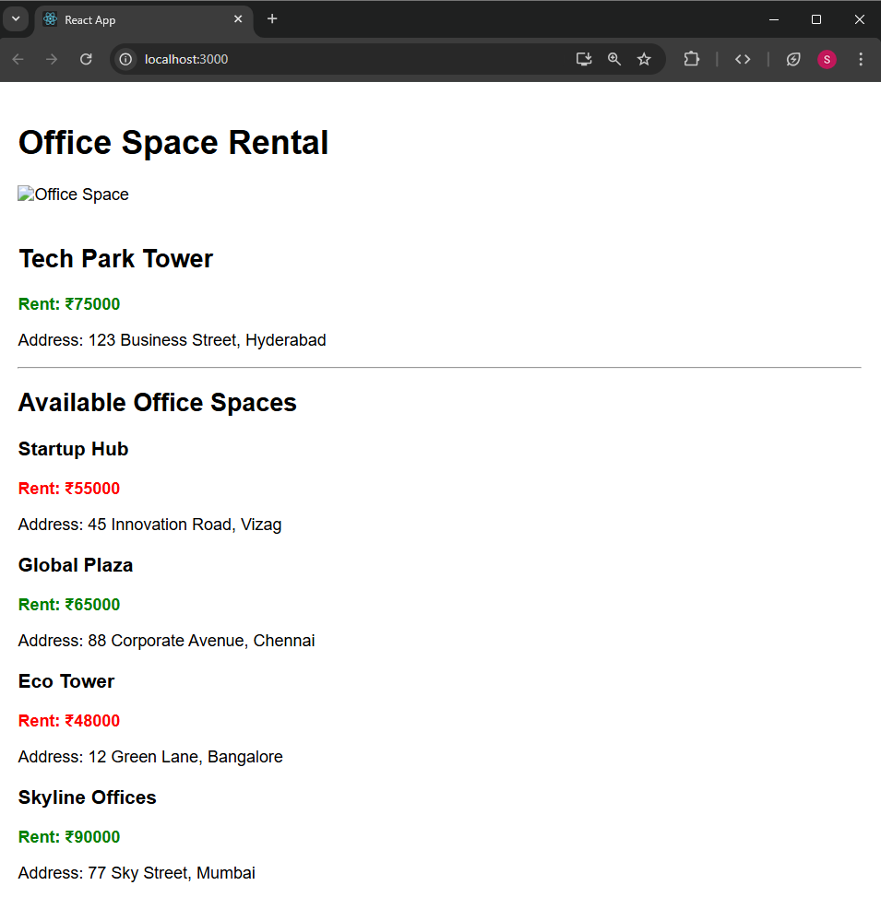export default App;

**11. ReactJS-HOL**

Src/components/Counter.js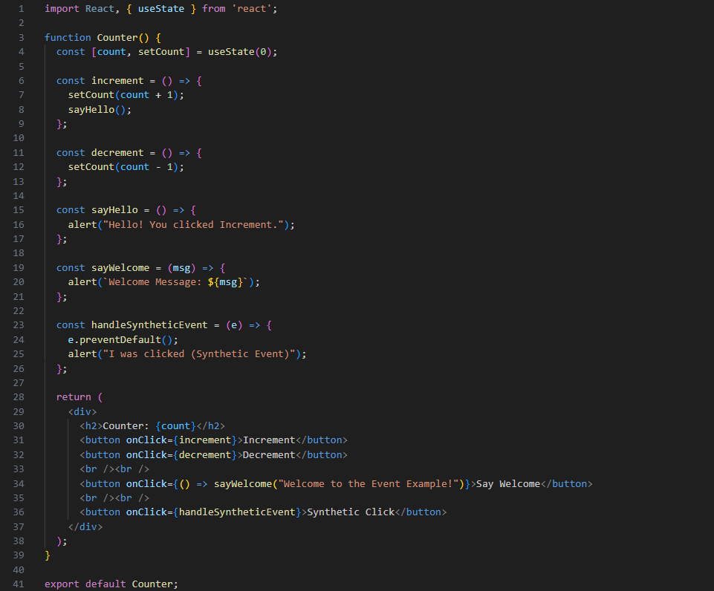

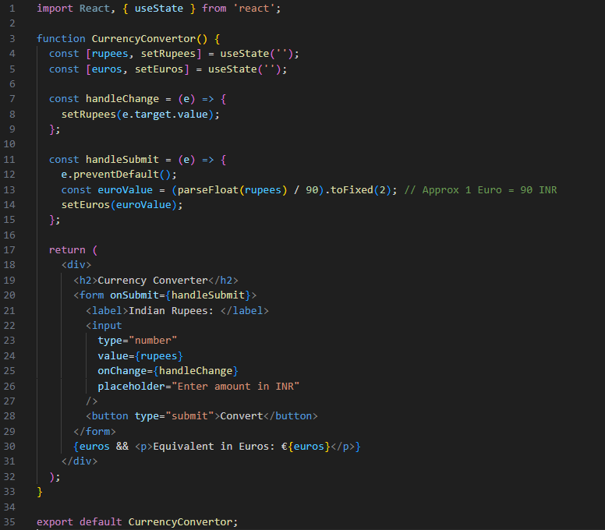

Src/components/CurrencyConvertor.js

App.js

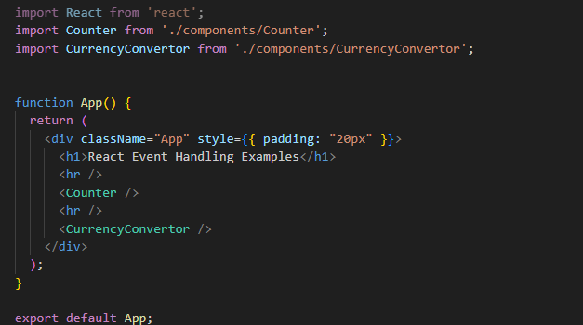

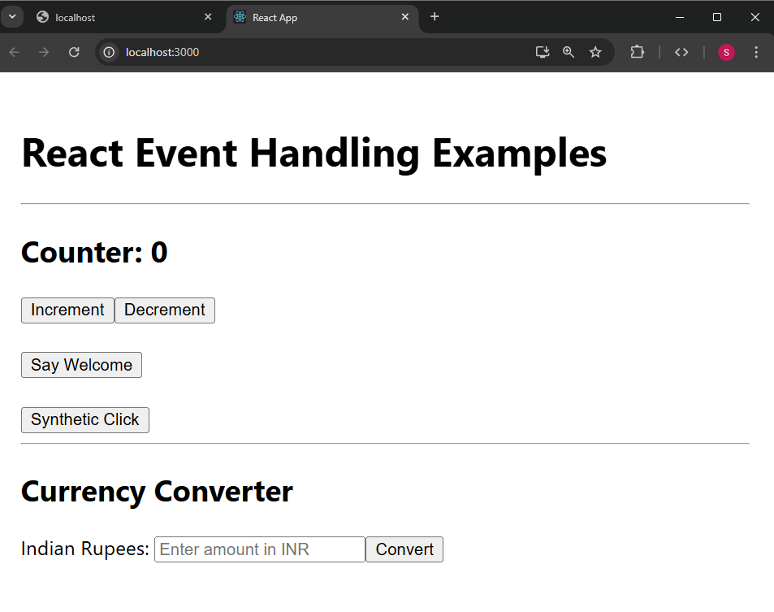

**12. ReactJS-HOL**

App.js

import React, { useState } from 'react';

function App() {

  const [isLoggedIn, setIsLoggedIn] = useState(false);

  const flights = [

    { id: 1, from: "Hyderabad", to: "Mumbai", price: 4500 },

    { id: 2, from: "Delhi", to: "Chennai", price: 5500 },

    { id: 3, from: "Bangalore", to: "Kolkata", price: 6000 }

  ];

  const GuestPage = (

    <div>

      <h2>Available Flights</h2>

      {flights.map((flight) => (

        <div key={flight.id} style={{

          border: "1px solid #ccc",

          padding: "10px",

          margin: "10px 0",

          borderRadius: "8px"

        }}>

          <p><strong>{flight.from}</strong> → <strong>{flight.to}</strong></p>

          <p>Price: ₹{flight.price}</p>

        </div>

      ))}

      <button onClick={() => setIsLoggedIn(true)}>Login</button>

    </div>

  );

const UserPage = (

    <div>

      <h2>Book Your Ticket</h2>

      <form>

        <label>From: </label>

        <input type="text" placeholder="Departure city" /><br /><br />

        <label>To: </label>

        <input type="text" placeholder="Arrival city" /><br /><br />

        <label>Date: </label>

        <input type="date" /><br /><br />

        <button type="submit">Book Ticket</button>

      </form>

      <br />

      <button onClick={() => setIsLoggedIn(false)}>Logout</button>

    </div>

  );

  return (

    <div style={{ padding: "20px", fontFamily: "Arial" }}>

      <h1>Ticket Booking App</h1>

      {isLoggedIn ? UserPage : GuestPage}

    </div>

  );

}

export default App;

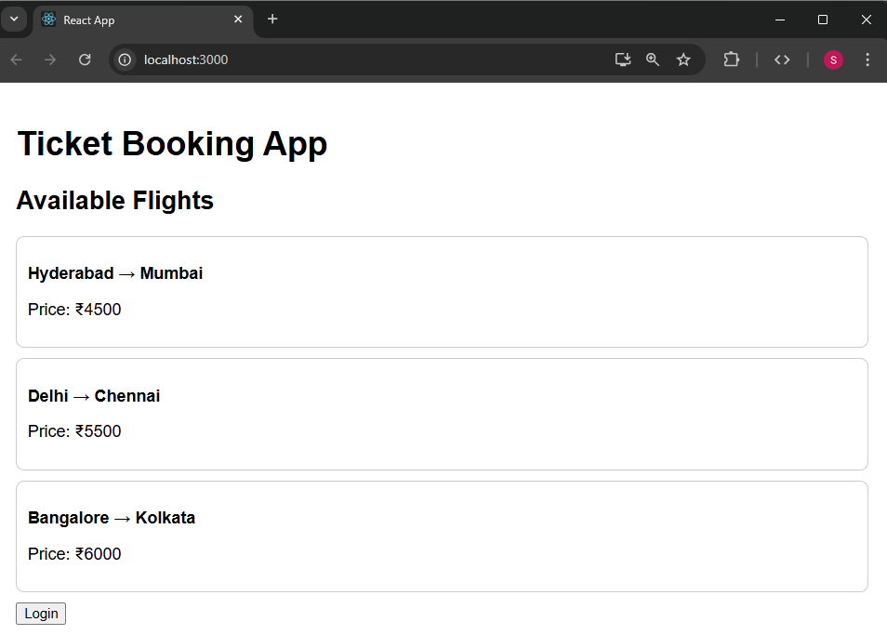

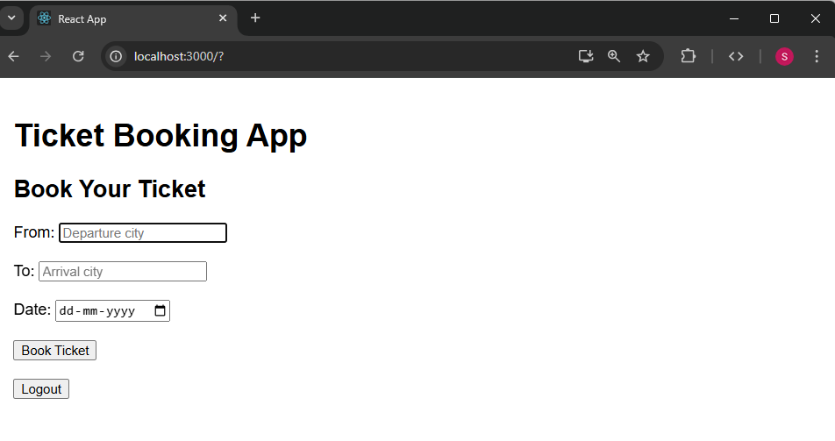

**13. ReactJS-HOL**

Src/components/BookDetails.js

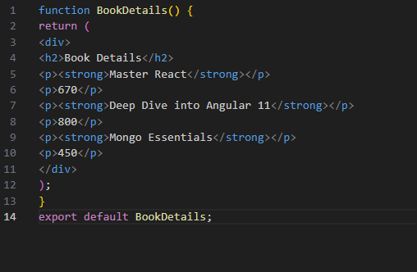

Src/components/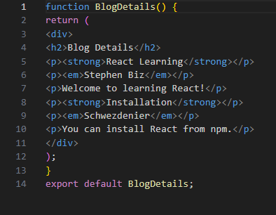BlogDetails.js

Src/components/CourseDetails.js

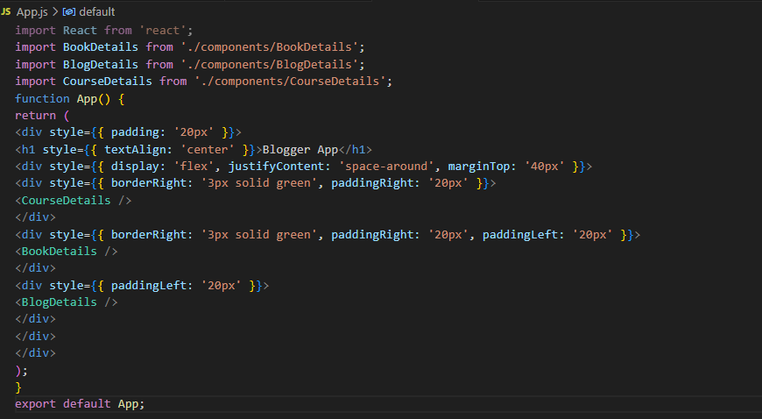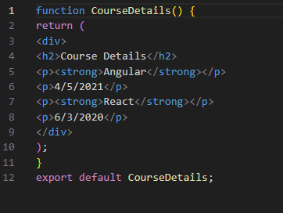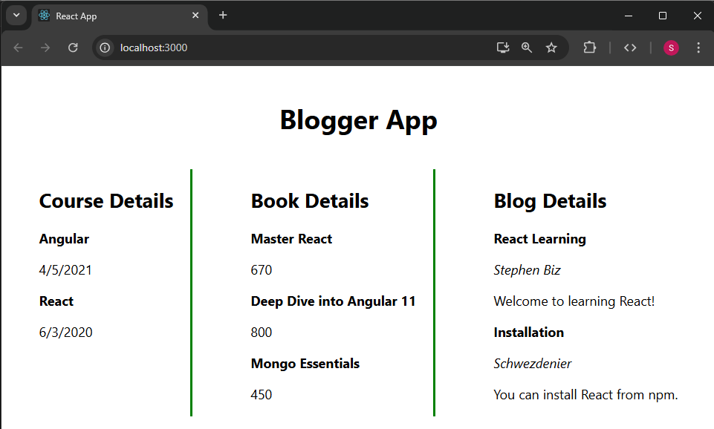

App.js